A PROJECT REPORT ON
MINI SEARCH ENGINE / INFORMATION RETRIEVAL SYSTEM
A Project Report submitted in partial fulfillment of the requirements for the course
DATA STRUCTURES AND ALGORITHMS - 3 (25CS2103E)
in
COMPUTER SCIENCE AND ENGINEERING / IT
ACADEMIC YEAR: 2026–2027
Submitted by:
K. Pavan Kumar – 2520090038
P. Harsha Vardhan – 2520090180
Team Number: 09 | Section: 12
Under the Guidance of:
Ms. K. Chandusha Mam
Assistant Professor, Department of Computer Science & Information Technology


K L (Deemed to be) University, Bachupally, Hyderabad – 500090, Telangana, India

DEPARTMENT OF COMPUTER SCIENCE & INFORMATION TECHNOLOGY
K L (DEEMED TO BE) UNIVERSITY

DECLARATION
We hereby declare that the project report entitled “MINI SEARCH ENGINE / INFORMATION RETRIEVAL SYSTEM” submitted for the course Data Structures and Algorithms - 3 (25CS2103E) is an authentic record of our own work carried out under the guidance of Ms. K. Chandusha Mam, Assistant Professor, Department of Computer Science & Information Technology, K L (Deemed to be) University.
The matter presented in this report has not been submitted by us for the award of any other degree or diploma in this or any other University/Institute.
Student Name(s) & ID(s):
1. K. Pavan Kumar – 2520090038
2. P. Harsha Vardhan – 2520090180
DEPARTMENT OF COMPUTER SCIENCE & INFORMATION TECHNOLOGY
K L (DEEMED TO BE) UNIVERSITY

CERTIFICATE
This is to certify that the project report entitled “MINI SEARCH ENGINE / INFORMATION RETRIEVAL SYSTEM” is a bonafide work carried out by K. Pavan Kumar (2520090038) and P. Harsha Vardhan (2520090180) (Team No. 09, Section 12) in partial fulfillment of the requirements for the course Data Structures and Algorithms - 3 (25CS2103E) during the academic year 2026–2027.
Ms. K. Chandusha
Project Guide & Assistant Professor, CSIT
Dr. Khaja Shareef (CSIT)
Head of Department, CSIT
ACKNOWLEDGEMENT
We express our sincere gratitude to Ms. K. Chandusha, Assistant Professor, Department of Computer Science & Information Technology, for her invaluable guidance, constant support, and encouragement throughout the duration of this project.
We are deeply thankful to Dr. Khaja Shareef (CSIT), Head of the Department, for providing the necessary academic infrastructure and resources required for the successful completion of this project work.
Finally, we extend our appreciation to our faculty members, peers, and family for their continuous motivation and technical assistance.
K. Pavan Kumar – 2520090038
P. Harsha Vardhan – 2520090180

TABLE OF CONTENTS

S.No. | Contents | Page No.
1. | Abstract
2. | Introduction
3. | Literature Survey
4. | Problem Statement & Objectives
5. | Hardware & Software Requirements
6. | Implementation
7. | Results & Discussion
8. | Conclusion & Future Scope
9. | References
1. ABSTRACT
This project presents the design and implementation of a Mini Search Engine / Information Retrieval System developed for the course Data Structures and Algorithms - 3 (25CS2103E). The primary objective of the system is to efficiently index, process, and retrieve relevant documents from a collection of text files based on user search queries. The core architecture relies on an Inverted Index constructed with hash-table-based dictionaries for fast term lookups and posting list retrieval. Input documents undergo a multi-stage pre-processing pipeline including text parsing, normalization, case conversion, and tokenization. For query execution, term matching is combined with Term Frequency-Inverse Document Frequency (TF-IDF) scoring to calculate relevance weights and deliver accurately ranked search results. The system demonstrates efficient query execution and scalable information retrieval suitable for localized document corpora and academic search applications.
2. INTRODUCTION
In the modern digital era, the massive growth of unstructured textual data necessitates effective tools for information organization and retrieval. Information Retrieval (IR) systems enable users to locate relevant documents within large collections quickly and accurately. The principal challenge in designing retrieval systems is minimizing query latency while providing precise, context-relevant results.
This project focuses on building a lightweight Mini Search Engine centered on fundamental data structures and algorithmic principles. By employing inverted indexes, hash tables, and TF-IDF relevance scoring, the engine transforms unorganized document collections into structured searchable repositories. This report details the system design, theoretical survey, component modules, implementation details, evaluation, and future scope of the project.

3. LITERATURE SURVEY
Information Retrieval systems have progressed from rudimentary full-text sequential scanning to modern dynamic vector space models. Early foundational work by Gerard Salton established the Vector Space Model (VSM) and TF-IDF term weighting schemes, providing mathematical abstractions for computing query-document relevance. Inverted indexes have long served as the fundamental data structure in search systems, mapping unique vocabulary terms to lists of document identifiers (postings) to eliminate linear scanning during query execution. Modern local retrieval systems utilize efficient hash tables for O(1) average-time dictionary lookups and dictionary-based term matching. This project synthesizes these established concepts to construct a localized, high-performance information retrieval system structured specifically around core C++/Python data structures.

4. PROBLEM STATEMENT & OBJECTIVES
4.1 Problem Statement
To design and implement a fast, memory-efficient Mini Search Engine capable of pre-processing text documents, constructing an inverted index, and executing ranked query retrieval with minimal latency.
4.2 Problem Description
Sequential line-by-line document scanning scales poorly with linear time complexity per search request, rendering direct pattern matching impractical for growing text collections. This project addresses the challenge by building an inverted index using hash table mappings and TF-IDF scoring to achieve rapid dictionary lookups and relevance-ranked search results.
4.3 Project Objectives
- To develop a document collection processing engine for file reading, text normalization, and tokenization.
- To construct an Inverted Index backed by hash tables for efficient dictionary lookups and postings list management.
To implement query term matching, TF-IDF calculation, and ranking algorithms to display search results in order of relevance.

5. HARDWARE & SOFTWARE REQUIREMENTS
5.1 Hardware Requirements
- Processor: Intel Core i3 / i5 or equivalent multi-core processor
- RAM: 4 GB minimum (8 GB recommended)
- Storage: Standard Hard Disk / Solid State Drive with sufficient space for text document storage
5.2 Software Requirements
- Operating System: Windows 10 / 11 or Linux / macOS
- Programming Language: Python 3.x / C++ 17
- Development Environment: VS Code / PyCharm / GCC Compiler
- Libraries & Tools: Standard Library / STL, File I/O utilities

6. IMPLEMENTATION
6.1 Module 1: Document Collection, Parsing & Tokenization
This module reads input text files from the corpus directory, normalizes letter casing, eliminates non-alphanumeric punctuation, and splits raw text streams into discrete tokens.

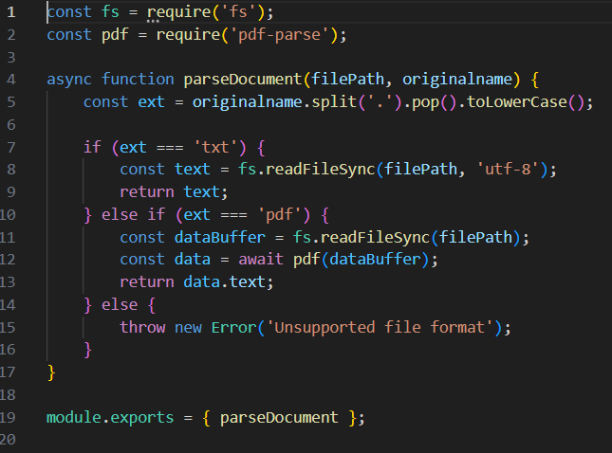
6.2 Module 2: Inverted Index & Hash Table Lookup
This module constructs the Inverted Index using hash-table-backed dictionaries to map extracted vocabulary terms to document postings and term frequency records.
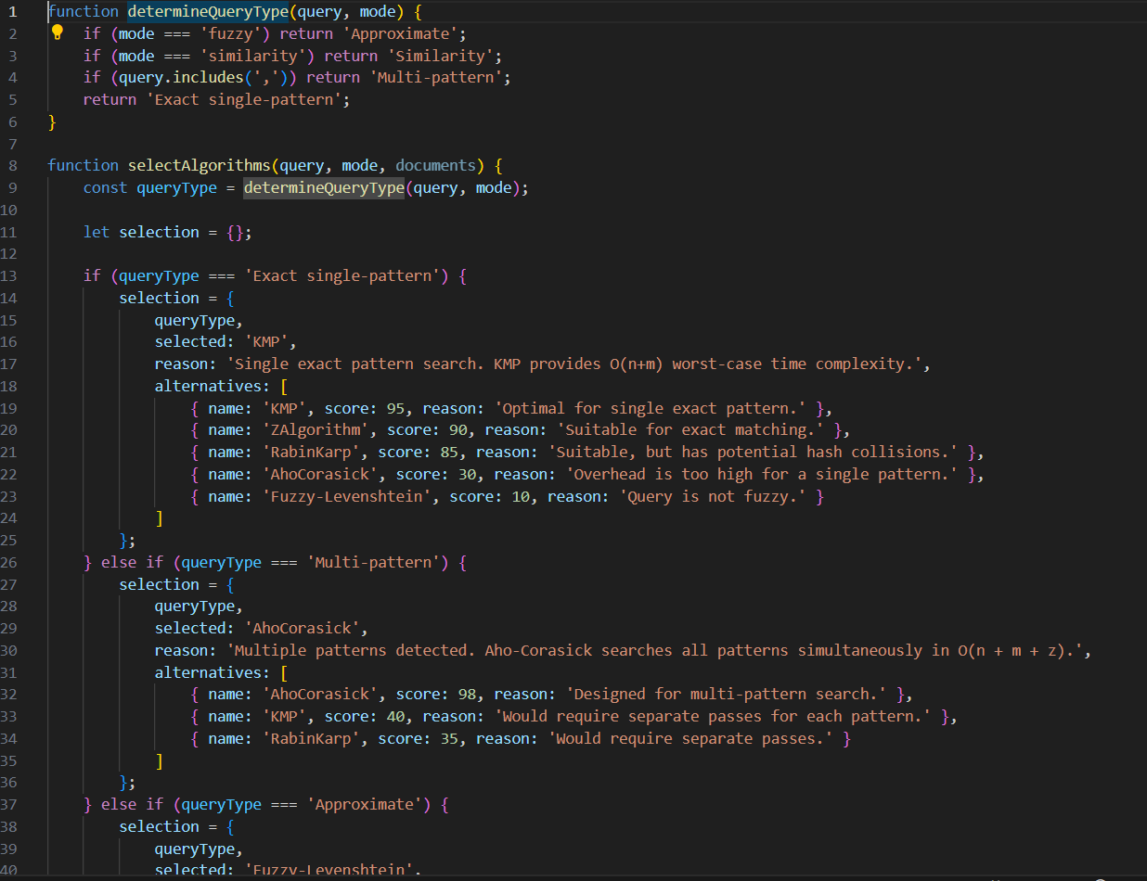
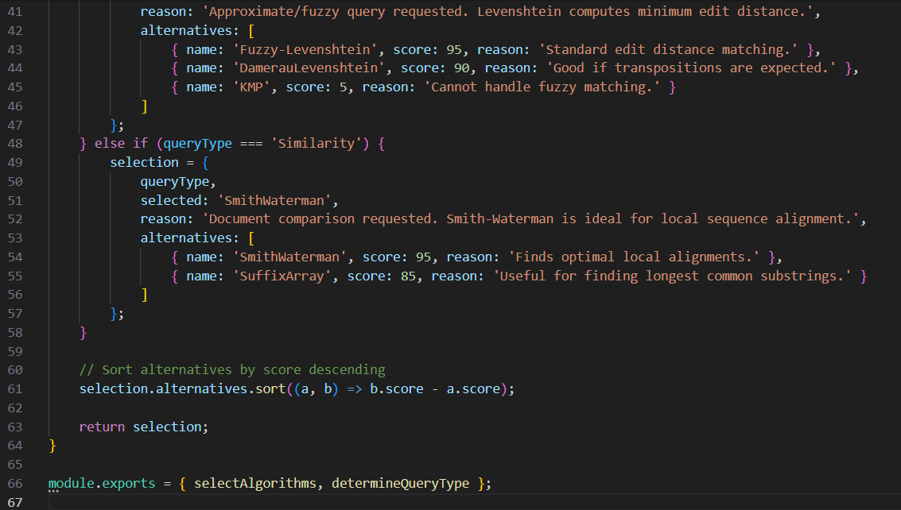

6.3 Module 3: Query Processing, Term Matching, TF-IDF Scoring & Ranking
This module accepts user queries, extracts query terms, retrieves corresponding posting lists from the inverted index, computes TF-IDF score weights, and ranks documents in descending order of relevance score.
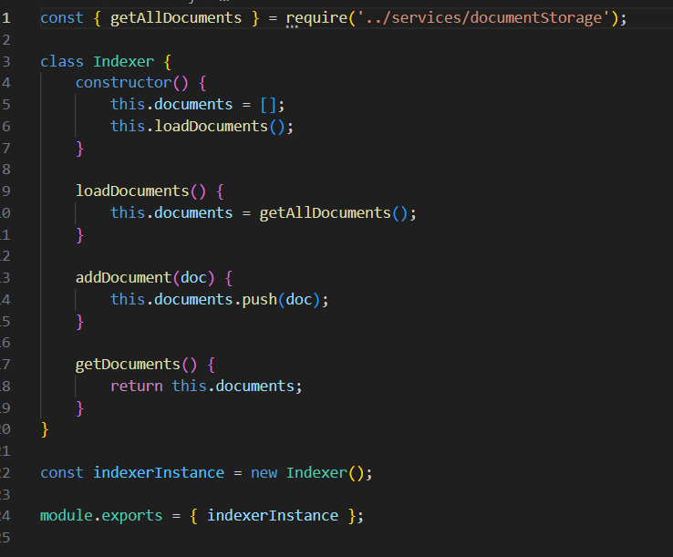
7. RESULTS & DISCUSSION
The Mini Search Engine was evaluated using a collection of sample text documents. The pre-processing pipeline successfully parsed the document text, normalized case, and constructed an efficient Inverted Index. When executing sample search queries, the system correctly retrieved documents containing matching terms and calculated TF-IDF relevance scores to present the search results in ranked order.
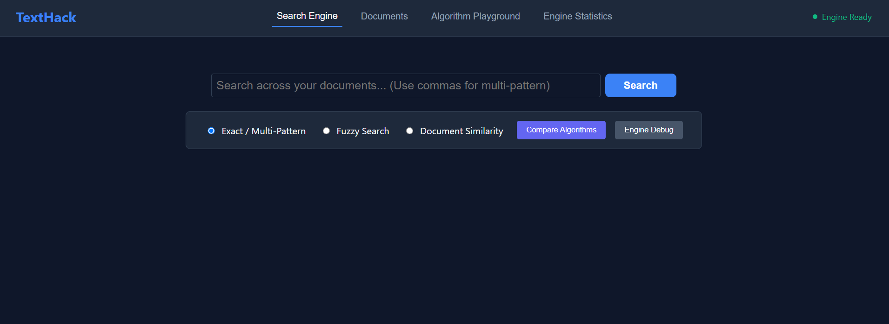


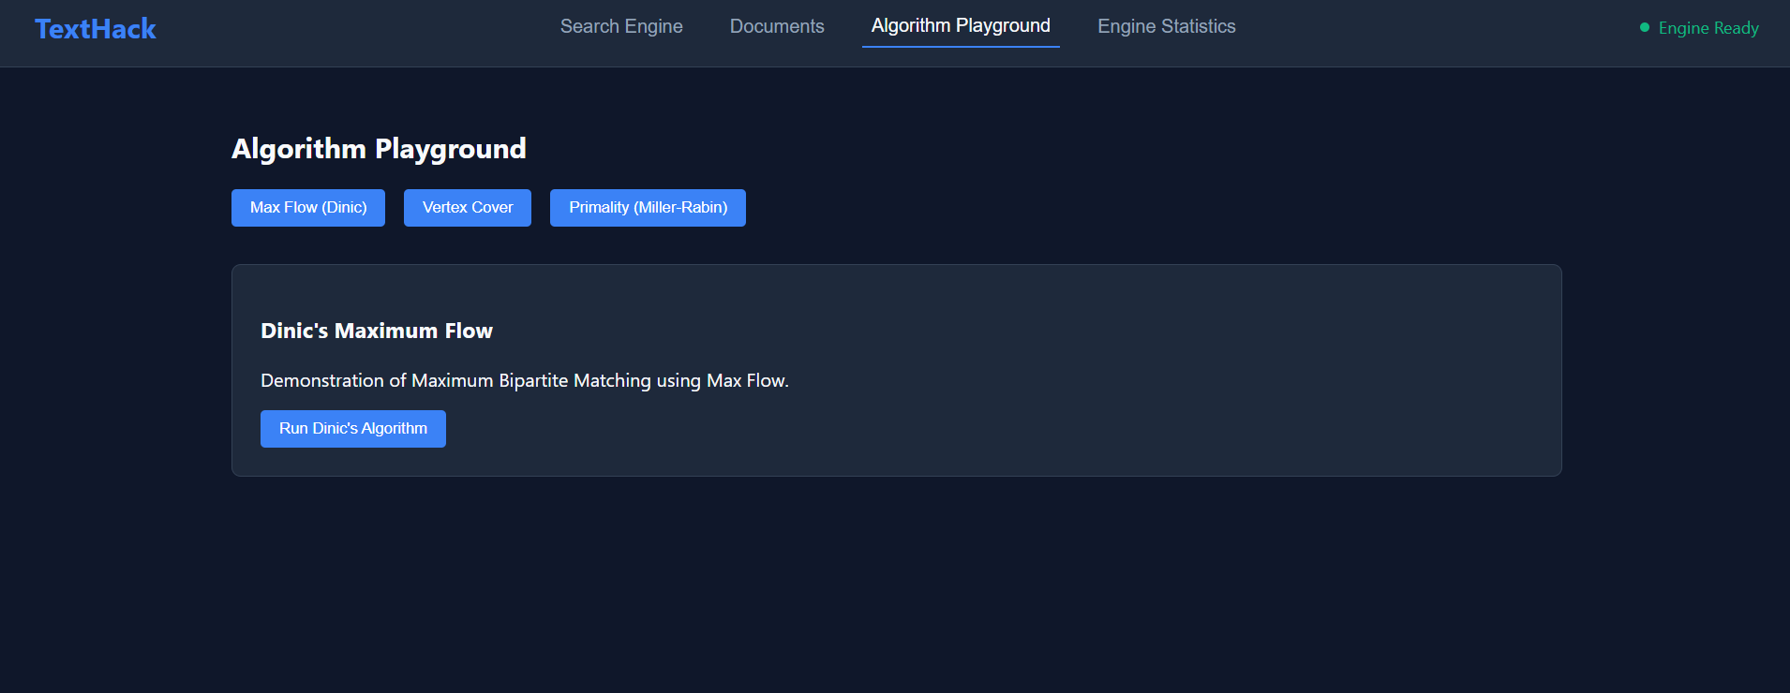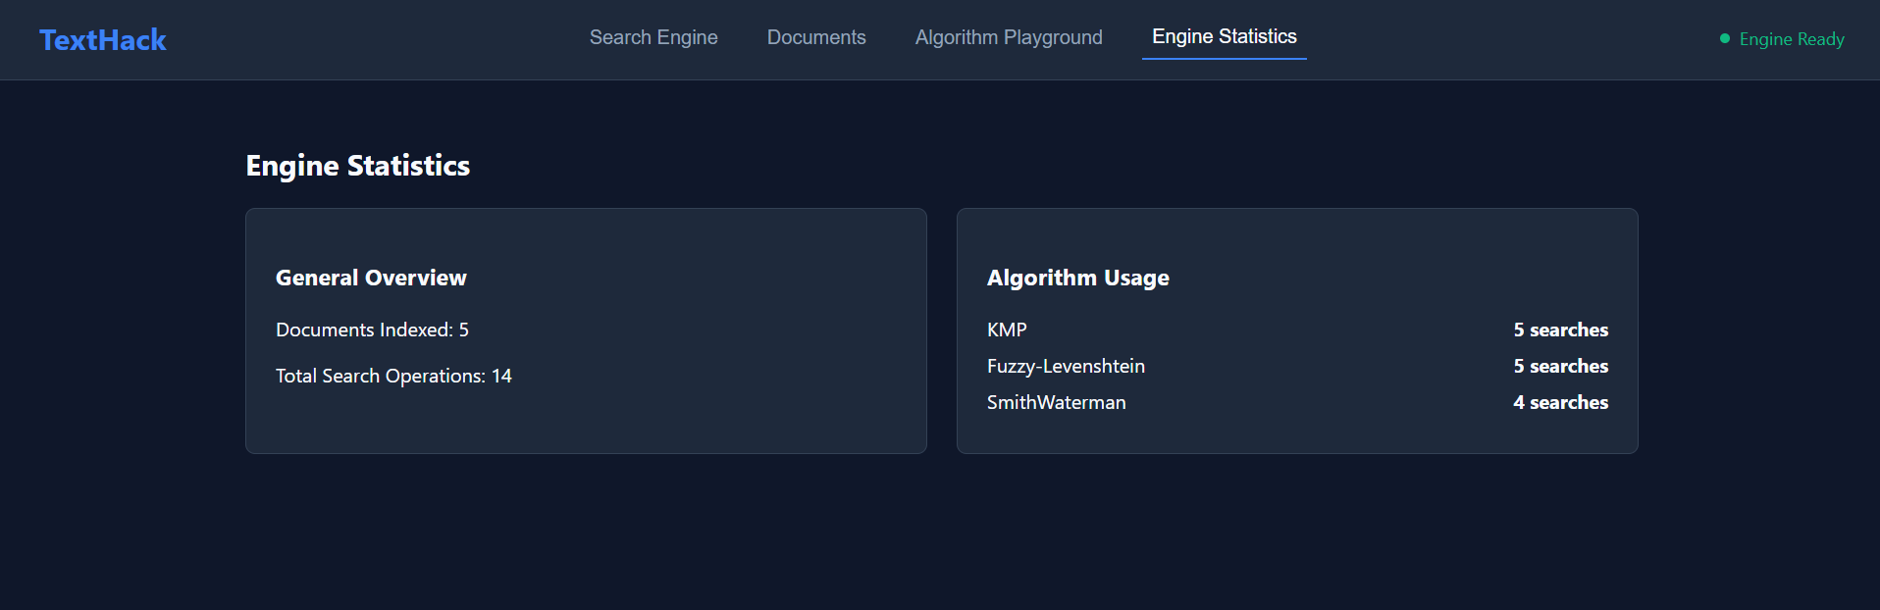

8. CONCLUSION & FUTURE SCOPE
In this project, a functional Mini Search Engine / Information Retrieval System was successfully designed and implemented. By utilizing efficient hash table structures for Inverted Index management, term tokenization, and TF-IDF relevance scoring, the engine effectively retrieves and ranks document search results. The project met all primary objectives, demonstrating the practical application of core data structures and algorithmic models in information retrieval.
Future enhancements include expanding the indexing module to support multi-word phrase queries, incorporating positional indexing, adding dynamic document indexing, and developing a graphical user interface (GUI) for interactive searching.

9. REFERENCES
- Salton, G., & McGill, M. J. (1983). Introduction to Modern Information Retrieval. McGraw-Hill.
- Manning, C. D., Raghavan, P., & Schütze, H. (2008). Introduction to Information Retrieval. Cambridge University Press.
- Croft, W. B., Metzler, D., & Strohman, T. (2010). Search Engines: Information Retrieval in Practice. Addison-Wesley.
- Cormen, T. H., Leiserson, C. E., Rivest, R. L., & Stein, C. (2009). Introduction to Algorithms (3rd ed.). MIT Press.
Baeza-Yates, R., & Ribeiro-Neto, B. (2011). Modern Information Retrieval (2nd ed.). Addison-Wesley.

